Which of the following are red-black BSTs?

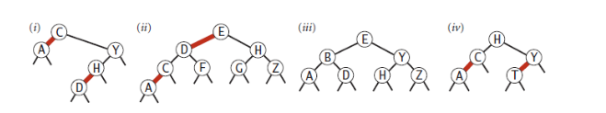

**iii and iv**

Of the given trees, only (iii) & (iv) are red-black binary search trees. As the number of black nodes from the root to leaf is constant.